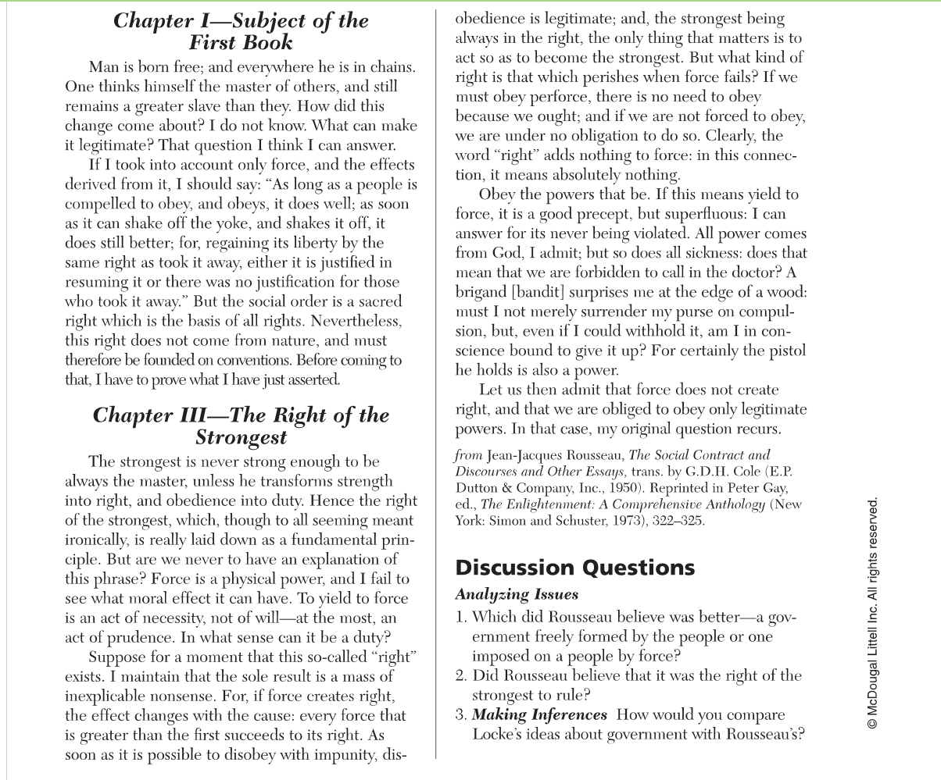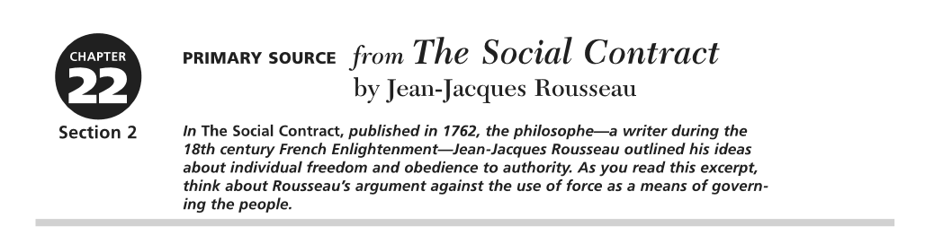

1. Rousseau believed that the government should be ran by the people and guided by society. According to the text, Rousseau states that the right does not come from nature but are founded on conventions.
2. Rousseau did not believe that the strongest should rule unless the people allow it. Rousseau believes the strongest should have the ability to transform their strength into right and obedience into duty. If they possess these traits, then they should be able to rule.
3. Locke’s idea is that the government should protect the natural rights, which are life, liberty and property. Meanwhile, Rousseau’s idea is about the people creating and controlling the government.